DIGITAL MULTIMETER OPERATION MANUAL
1. SUMMARIZE
The meter is a stable multimeter with 3 2/1 LCD display, 9Vdriven by battery. It's widely used on measuring Inductance, resistance, capacitance, diode ,transistor rest and continuity buzzer. It’s an ideal tool for lab, factory and family.

2. SAFETY NOTE
The meter meets the standards of IEC1010. Read the operation manual carefully before operation.
1．Do not input DC Voltage or AC Voltage.
2．The voltage below 36V is safety. To avoid electric shock, check whether the test leads are connected correctly, whether the insulation is good when measuring over 36DCV or 25ACV, .
3．Remove the test leads when changing function and range.
4．To select correct function and range, beware of error operation.；
5．SAFETY SYMBOLS
“”THE OPERATOR MUST REFER TO THE MANUAL ，“”LOW BATTERY
3. Technical data
Function Model
Inductance | 2mH-20H
Capacitance | 2nF-1000uF
Resistance | 200Ω-20MΩ
Diode test | √
Transistor Test | √
Continuity buzzer | √
Data Hold | √
Alarm | √
4. CHARACTERISTIC
1．GENERAL
1-1．Displaying: LCD displaying.
1-2．Max. displaying: 1999（3 1/2 digit）auto polarity indication.
1-3．Measuring method: dual slope A/D conversion.
1-4．Sampling rate: approx. 3 times/second.
1-5．Over range indication: the MSD displays“1”.
1-6．Low battery indication:“” appears.
1-7．Operation environment: （0～40）℃，R.H.<80% .
1-8．Power：9V×1（NEDA1604/6F22 or equivalent model）.
1-9．Size:189×97×35mm
1-10．Weight: approx. 380g（including battery）.
1-11. Accessory: operation manual, gift box, test leads, and battery.

2．TECHNICAL CHARACTERISTIC
Accuracy:±(a%×rdg＋d) at (23±5)℃，R.H.<75%，one year guaranteed from the production date.
2-1. Inductance(L)
RANGE | ACCURACY | RESOLUTION | MEASURE FREQUENCY
2mH | ±(2.0%+5d) | 1uH | About 200Hz
20mH | ±(2.0%+5d) | 10 uH | About 200Hz
200mH | ±(2.0%+5d) | 100uH | About 200Hz
2H | ±(5.0%+5d) | 1mH | About 200Hz
20H | ±(5.0%+15d) | 10mH | About 200Hz
1H=10³mH=10⁶uH
2-2.CAPACITANCE(C)
RANGE | ACCURACY | RESOLUTION | MEASURE FREQUENCY
2nF | ±(1.0%+5d) | 1pF | About 200Hz
20nF | ±(1.0%+5d) | 10pF | About 200Hz
200nF | ±(1.0%+5d) | 100pF | About 200Hz
2uF | ±(2.0%+5d) | 1nF | About 200Hz
20uF | ±(2.0%+5d) | 10nF | About 16Hz
200uF | ±(5.0%+5d) | 100nf | About 16Hz
1000uF | ±(5.0%+25d) | 1uF | About 8Hz

2-3.RESISTANCE（Ω）
RANGE | ACCURACY | RESOLUTION
200Ω | ±(0.8%+5d) | 0.1Ω
2kΩ | ±(0.8%+3d) | 1Ω
20kΩ | ±(0.8%+3d) | 10Ω
200kΩ | ±(0.8%+3d) | 100Ω
2MΩ | ±(0.8%+3d) | 1kΩ
20 MΩ | ±(1.0%+15d) | 10 kΩ

5. OPERATION

5.1 Front panel description
1. LCD display
2. Transistor test jack.
3. Hold switch: use hold the measuring data.

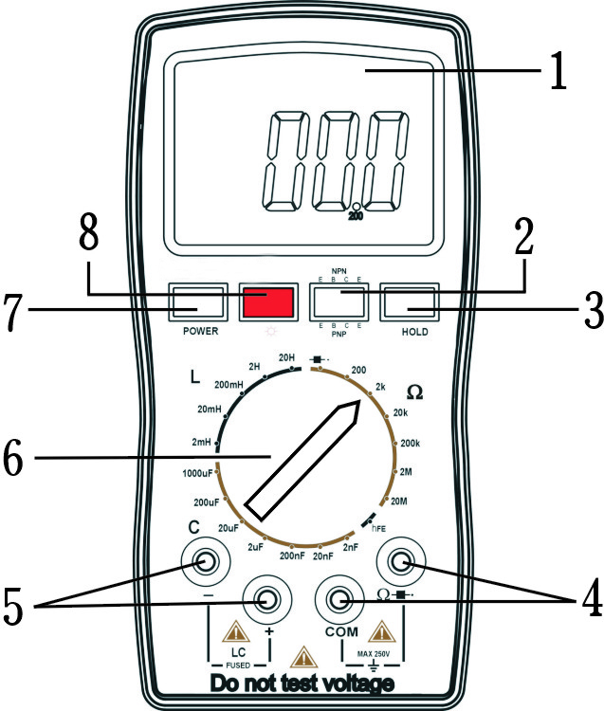

4. Range knob
5. Input port: the input port of resistance and diode test.
6. Input port: the input port of inductance and capacitance measuring..
7. Power switch.
8. Light diode: using in the Continuity buzzer

5-2 CONSIDERATION OF MEASUREMENT
- This LC METER is intended for measuring the capacitance value of a capacitor, the inductance value of an inductor. It is not intended for determining the “Q” factor for above reactive components. Misleading readings may be obtained if the measurement of the inductance or capacitance of a resistor is attempted.
- When measuring components in circuit, the circuit must be switched off and de-energized before connecting the test leads.
- For all measurements, should connect BLACK test lead to “-” terminal and RED test lead to “+” terminal.

5-3.INDUCTANCE (L) MEASUREMENT PROCEDURE
- Set POWER switch to “ON” position.
- Select the range switch for the maximum expected inductance.
- Connect the alligator clips to the inductor leads.
- Read the display. The value is direct reading in the electrical units (uH, H) indicated at the selected switch. If DISPLAY show “1”. It indicates on Out-of-Range measurement. If the display indicates one of more reading zeros, shift to the next lower range scale to improve the resolution of the measurement.

NOTE:
- If the inductance value is unmarked, start from the 2mH range and keep increasing until the over range indication goes off and a reading is obtained.
- Very low inductance measurement should be performed by using extremely short leads in order to avoid introducing any stray inductance.
- This instrument is not intended for determining the “Q” factor for the inductor. Misleading readings may be obtained if the measurement of the inductance of a resistor is attempted.

5-4.CAPACITANCE(C) MEASURING PROCEDURE
- Set POWER switch to “ON” position.
- Select the range switch for the maximum expected capacitance.
- Fully discharge any capacitors.
- Connect the alligator clips to the capacitor leads.
- Read the display. The value is direct reading in the electrical unit (nF, uF) indicated at the selected range switch. If DISPLAY show “1”, It indicate on Out-of-Range measurement. If the display indicates one or more leading zeros, shift to the next lower range scale to improve the resolution of the measurement.

NOTE:
- If the capacitance value is unmarked, start from the 2nF range and keep increasing until the over-range indication goes off and a reading is obtained.
- A shorted capacitor will read over-range on all ranges. A capacitance with low voltage leakage will read over range, or a much higher value than normal.
An open capacitor will read zero on all ranges (possible a few pF on 2nF range, due to stray capacitance of the instrument).
- Very low capacitance measurement should be performed by using extremely short leads in order to avoid introducing any stray inductance.
- When using the optioned test leads, remember that the leads introduce a measurable capacitance to the measurement. As a first approximation, the test capacitance did measured by opening the leads at the trips, recording the open circuit value and subtracting the value.
- Capacitors, especially electrolytic, often have notoriously wide tolerances. Do not be surprised if the measured value is greater than the value marked on the capacitor, unless it is a close tolerance type. However, value is seldom drastically below the rated value.

5-5. RESISTANCE(Ω) MEASURING PROCEDURE
- Set POWER switch to “ON” position.
- Select the range switch for the maximum expected resisitance.
- Insert the black test leads into the “COM” jack, and the red one into the “V/Ω/Hz” jack;
- Turn the range switch to resistance position, then connect the test leads at the two ends of the resistor.
- If DISPLAY show “1”, It indicate on Out-of-Range measurement. If the display indicates one or more leading zeros, shift to the next lower range scale to improve the resolution of the measurement.

Note:
1. When input is open circuit, it will display status 1;
2. When measuring resistance on line, ensure that all power of circuit tested are turn down and all capacitor are discharged completely;
3. Never input voltage if in resistance measurement mode!
4. It normal for resistance higher than 1MΩ that the reading data is not stable for the first several seconds;

5-6. Transistor hFE
1.Set POWER switch to “ON” position
2. Turn the range switch to “hFE” position;
3. To determine the transistor’s type, NPN or PNP, insert the emitting, base and collector electrode into the corresponding jacks in testing accessory.

5-7. DIODE AND CONTINUITY TEST
1.Set POWER switch to “ON” position.
2. Insert the black test leads into “COM“ jack, and the red one into the “Ω ” jack;
3. connect test leads in parallel to the diode tested, with the red test leads to the anode and the black to cathode, then the reading value will be approximate forward voltage drop of the diode;
4. Connect pencils to two points of the circuit to be tested, if buzzer sounds, then the resistance between the two points is lower than (60±20)Ω.

5-8 DATA HOLD
Press HOLD, the peak value of current data will be keep displaying on LCD; press it again to cancel this function.

6. MAINTENANCE
DO NOT try to verify the circuit for it’s a precision meter.
1.Beware of waterproof, dustproof and shockproof.
2.Do not operate and store the meter in the circumstance of high
temperature, high humidity, and flammability, explosive and strong
magnetic field.
3.Use the damp cloth and soft solvent to clean the meter, do not use
abrasive and alcohol.
4. If do not operate it for a long time, should take out the battery.
5.When LCD displays “ ” symbol, should replace the
battery as below:

●The specifications are subject to change without notice.
●The content of this manual is regarded as correct, error or omits Pls. contact with factory.
●We hereby will not be responsible for the accident and damage caused by improper operation.
●The function stated for this User Manual cannot be the reason of special usage.

MB-6243+-01

